

It’s week five. That time when assignments start to come in, energy begins to run out, and the spectre of the mid-semester exams looms. However, fear not brave Brucies, for now is also a time when the green shall run rampant, the leaves shall embrace you and the winter may slowly start to extend it’s icy touch, saving you from your too-warm rooms. Time goes on, and so don’t get too stressed, for the mid-semester break is soon going to be upon us!

*Doing it for Bill since 2014*

THE BRUCE BILLITIN

**ISSUE 06: Tuesday 15th March- Sunday 20th March**

*Doing it for Bill since 2014*

THE MANY WONDERS OF CANBERRA



Canberra is sure to light up this next week, getting autumn going with a bang! So have a look at these rib tickling events for this next week

* **Canberra Comedy Festival 15th March – 20th March-** Head to the canberracomedyfestival.com.au for information as to the world class line up of rib ticklers and pun makers for you all to see
* **Skyfire 2016 Saturday 19th March –** Yet another great thing in March, Skyfire is a massive fireworks display held over Lake Burley Griffin along with plane acrobatics and the cast of Home and away (oh goody…..)
* **Art Not Apart 19th March 1-7pm+ afterparties –**  Canberra’s quirkiest festival (that’s saying something), this is one Canberra experience not to miss, with art displays, musical acts, and a giant nightclub being formed from the shipping containers by the lake.

BRUCE HALL: An interactive Guide

While Canberra day may afford you an extra day to catch up on all those readings (or a hangover), Bruce has got plenty on to ensure that you fall behind straight away!

* **Tuesday 15th March 7pm Tim Mansfield’s Farewell:**  He was our deputy head of hall last year, and made an impact on all of our lives, so come down to the dining hall and show your appreciation for Tim and farewell a great man, and a friend to so many of us.
* **Thursday 17th March 5-6pm Brian Schmidt is coming to Bruce:** If you have any questions regarding the plans for Bruce, come along and ask our Vice Chancellor.
* **Thursday 17th March 8pm Irish Pub Night:** Whether you feel the need to go green, or just enjoy connecting with our countries Irish heritage, the Bruce Hall Buttery has got you covered with what is sure to be a great night (far better than ANU bar’s one…. )

SCHIMDT HAPPENS- What’s on in ANU

When not planning the mass movement of students, the chancellery occasionally does like to hold events around the university, such as multiple public lectures, as found below:

* **The cost of conflict: Five years of the Syria Crisis (**15th March 5:30-6:30 JG Crawford building)
* **Playing the game: the memoirs of Sir Julius Chan** (17th March 5:30-7:30 JG Crawford Building)
* **India- Australia Ties: Glimpses through a diplomat’s diary** (22nd March 3pm Hedley Bull Building.

For more information head to www.anu.edu.au/events

*They can take our halls, but they can never take our FREEEEEDOM*- Bill Wallace



MELBOWES GUIDE TO COFFEE ON CAMPUS

**While I sit in my room grinding coffee and carefully timing the length of my pourover, I sometimes look out of my haven of obscure german bangers and see a dazed, baggie eyed non-caffeinated person, and I feel in the depths of my heart pity. Pity. And that pity has driven me to write the following list.**

Coffee Grounds

**Coffee:** Subtle notes of burnt beans, with a faint hint of ‘I’m a law student’ and gritty aftermouth feel. Maybe they should learn how to grind at grounds. Ha.  **Atmosphere:** A good meeting place, with a (sometimes) excellent view of all those people working out.

**Rating:** Solid 7/10

Degree

**Coffee:** Said to be the best on Campus, maybe they should learn to heat their coffee to lower degrees, because this is one to go for if you enjoy that lovely burnt tongue feel.

**Atmosphere:** A great place for laughing at other’s despair as they slowly tramp to their lectures

**Rating:** 5/10

The Gods:

**Coffee:** After a recent staffing change Gods has moved forward in leaps and bounds, with a barista said to be pretty awesome. Until you taste his coffee that is.

**Atmosphere:** With overly loud music, and a perpetual queue, Gods atmosphere is one which comes in heaps but can be a bit much

**Rating: 6/10**

Street Theatre Café:

**Coffee:** A distant but smooth blend, with a subtle hint of an angry man making it.

**Atmosphere:** Relaxed, and a nice place to escape from the union court crowd.

**Rating: 6/10**

Dining Hall Machine

**Coffee:** Sweet and complex, a surprising blast on your early morning senses

**Atmosphere:** Unbeatable. A truly historic atmosphere.

**Rating: 10/10**





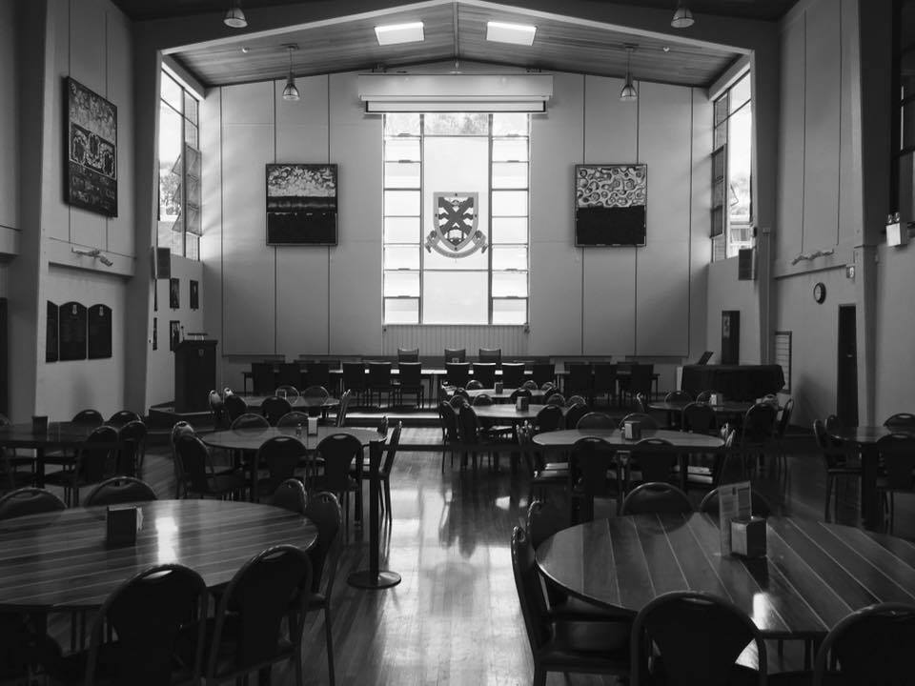

**Sports**

After finishing Tennis with a bang, the two sports which remain this term are basketball and the always exciting Road Relay. Basketball games continue this week at the following times:

* Girls: 2:30pm Thursday
* Guys: 1:30pm Thursday

**Arts**

You may have heard the whisper in the wind. The force may have touched you to. Because last year it certainly touched Guy Leckenby in the Interhall talent contest as he represented us with his very fine lightsaber talents. This year that could be you, so sign up and get ready for the Tryouts this Friday in the JCR.  
The signup sheet is in the foyer.

Representing the Dragon

TRIVIA

1. What Winter Olympics did the Jamaican Bobsled team debut at? 7. Which city in England are the Arctic Monkeys from?

2. What year did Julius Caesar Die? 8. What scientific term refers to replication of cells within an

3. For what film did Kate Winslet win Best Actress? Organism?

4. What year did Liechtenstein’s last murder occur in? 9. Who is the current head of the Australian Defence Force?

5. Who wrote Crime and Punishment? 10. What is the name for Donald Trump’s hairstyle?

6. In what century where the rules of Cricket first written?

1. 1988 Calgary Olympics, 2. 44BC, 3. The Reader, 4. 1997, 5. Fyodor Dostoevsky, 6. 18th Century, 7. Sheffield, 8. Mitosis, 9. Air Chief Marshal Mark Binskin, 10. A Comb-over